Celsus, an encounter with centenary vineyards

Toro, October 2025. Celsus originates mainly from a 0.80-hectare plot planted in 1920, located just a couple of kilometres from the winery. Known as La Lola, this vineyard, like many others in the D.O., is a blend of Tinta de Toro with a small percentage (approximately 10%) of Garnacha and a few Malvasía vines.
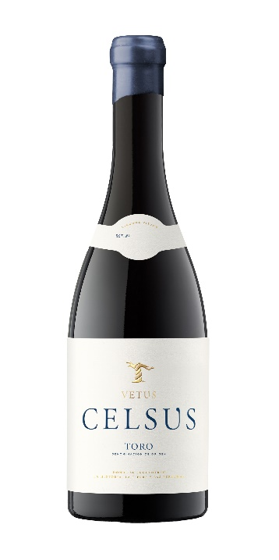
Paradoxically, from this vineyard, which is so unique in terms of age, configuration and yields, Bodegas Vetus produces its most exquisite wine (hence the name Celsus), of which only 2,680 bottles will be sold for this 2023 vintage. Celsus is a glimpse into the great vineyards of Toro, the oldest ones, those that have given it its name and have crossed borders. La Lola is cultivated as in the past, following organic viticulture criteria and allowing it to express itself, without major interventions.

After being harvested by hand, it ferments in small 3,000-litre stainless steel tanks (malolactic fermentation in used Bordeaux barrels) before maturing for 12 months in 500-litre barrels and amphorae (one third of the total).

The new 2023 vintage, which has been eagerly awaited (no wine was produced in 2022), also features a new design, with a Burgundy bottle and a special box of six bottles. On tasting, Celsus displays a cherry colour with a garnet rim; aromas of ripe fruit, powerful, toasted, with chocolate and mineral notes. On the palate, it is flavourful, meaty and marked with spices.

PVP: 50,20 € (www.artevinostore.es)
Notes: Bodegas Vetus is located in Toro, with a 20-hectare organic estate where it produces its DO Toro wines: Flor de Vetus, Vetus and Celsus. It is part of Artevino Family Wineries, which also includes Izadi and Orben, DO Ca Rioja, and Finca Villacreces, DO Ribera del Duero.

Bodega Vetus - Iván Pérez - iperez@artevino.es - 616 510 586

